

**Product Dissection for Instagram**

**Company Overview:**

Instagram is a widely-used social media platform launched in 2010, initially focusing on photo-sharing. Over the years, it has evolved into a comprehensive platform for sharing photos, videos, stories, and more, with a user base spanning across the globe. In 2012, Facebook acquired Instagram, further solidifying its position in the social media landscape. Instagram has become a hub for content creators, influencers, businesses, and individuals alike, offering various features to engage users and foster connections.

**Product Dissection and Real-World Problems Solved by Instagram:**

Instagram, as a prominent social media platform, addresses real-world challenges through its innovative product features and services, facilitating connection, expression, and engagement among users. By focusing on enhancing user experience and providing diverse functionalities, Instagram effectively tackles various challenges encountered in the realm of social networking.

**Problem 1: Limited Personal Connection:**

Real-World Challenge: In the digital age, individuals often face challenges in maintaining personal connections due to factors such as distance, busy schedules, and differing time zones. This limitation hinders meaningful interactions and sharing of experiences among friends, family, and acquaintances.

**Instagram's Solution:**

Instagram offers a solution to the challenge of limited personal connection through features like direct messaging, stories, and live video. Direct messaging enables users to engage in private conversations, fostering personal connections regardless of geographical barriers. Stories and live video allow users to share real-time moments and experiences, creating a sense of immediacy and authenticity in their interactions. These features facilitate meaningful connections among users, overcoming the constraints of physical distance and time.

**Problem 2: Content Discovery Overload:**

**Real-World Challenge**: With the abundance of content available online, users often face challenges in discovering relevant and engaging content tailored to their interests. Navigating through a vast array of content can be overwhelming and time-consuming, leading to a suboptimal user experience.

**Instagram's Solution:**

Instagram addresses the challenge of content discovery overload through its Explore page and algorithmic feed. The Explore page curates personalized content recommendations based on user interests, interactions, and trending topics, enabling users to discover new accounts, posts, and trends aligned with their preferences. The algorithmic feed prioritizes content from accounts that users engage with the most, ensuring a tailored and relevant content experience. By leveraging these features, Instagram streamlines content discovery and enhances user satisfaction, making it easier for users to find and engage with content that resonates with them.

**Problem 3: Authenticity and Trust:**

**Real-World Challenge**: In the era of digital communication, authenticity and trust are essential factors in fostering meaningful connections and building relationships. However, users often encounter challenges in discerning authentic content and trustworthy accounts amidst the proliferation of fake news, misinformation, and online scams.

**Instagram's Solution:**

Instagram addresses the challenge of authenticity and trust through various measures aimed at promoting transparency and credibility. Verified accounts with blue checkmarks signify authentic and notable accounts, helping users identify trusted sources of content. Additionally, features like Stories and Reels enable users to share unfiltered, candid moments, fostering authenticity and genuine connections with their audience. Instagram also implements community guidelines and content moderation policies to combat misinformation and maintain a safe and trustworthy platform. By prioritizing transparency, authenticity, and safety, Instagram instills confidence in users and fosters a positive user experience conducive to meaningful interactions and relationships.

**Problem 4: Privacy and Security Concerns:**

**Real-World Challenge:** With the increasing prevalence of cyber threats and data breaches, users are increasingly concerned about safeguarding their privacy and personal information online. Privacy breaches, account hacking, and unauthorized access to personal data pose significant challenges to user trust and confidence in social media platforms.

**Instagram's Solution:**

Instagram addresses privacy and security concerns through robust security features and privacy settings designed to protect user accounts and personal information. Two-factor authentication enhances account security by requiring additional verification for login attempts, reducing the risk of unauthorized access. Privacy settings enable users to control their account visibility, content sharing preferences, and interactions with other users, empowering them to manage their online privacy effectively. Additionally, Instagram implements encryption protocols to secure user data and communication channels, minimizing the risk of data breaches and unauthorized access. By prioritizing user privacy and security, Instagram builds trust and confidence among users, fostering a safe and secure environment for social interaction and content sharing.

**Problem 5: Content Monetization and Creator Support:**

**Real-World Challenge:** Content creators and influencers often face challenges in monetizing their content and sustaining their creative endeavors on social media platforms. Limited monetization opportunities, fluctuating algorithms, and platform policies can hinder creators' ability to earn a sustainable income and thrive in the digital landscape.

**Instagram's Solution:**

Instagram addresses the challenge of content monetization and creator support through various features and initiatives aimed at empowering creators and facilitating monetization opportunities. Features like Instagram Shopping and Checkout enable creators to tag and sell products directly from their posts, providing a seamless shopping experience for users and generating revenue for creators. Additionally, Instagram offers monetization opportunities through branded content partnerships, where creators collaborate with brands to create sponsored content in exchange for compensation. Instagram also supports creators through initiatives like IGTV ads, where creators earn a share of revenue from ads displayed in their IGTV videos. By offering diverse monetization avenues and creator support programs, Instagram empowers content creators to monetize their creativity and build sustainable careers on the platform.

**Case Study: Real-World Problems and Instagram's Innovative Solutions**

**Instagram**, as a leading social media platform, effectively addresses real-world challenges through its innovative product features and initiatives aimed at enhancing user experience, fostering meaningful connections, and supporting content creators. By prioritizing authenticity, privacy, and creator empowerment, Instagram has established itself as a trusted platform for social interaction, content sharing, and community building.

**Top Features of Instagram:**

**1.** **Feed:** Instagram's feed displays photos and videos shared by users and accounts followed by the user, fostering content discovery and engagement.

**2.** **Stories:** Instagram Stories allow users to share ephemeral photos and videos that disappear after 24 hours, enabling real-time sharing of moments and experiences.

**3. Explore:** The Explore page curates personalized content recommendations based on user interests, interactions, and trending topics, facilitating content discovery and exploration.

**4.** **Direct Messaging:** Instagram's direct messaging feature enables private conversations and group chats among users, fostering personal connections and communication.

**5.** **Reels:** Instagram Reels allows users to create and share short-form videos set to music, fostering creativity and engagement among users.

**6. IGTV:** Instagram's IGTV feature enables users to share long-form vertical videos, providing a platform for creators to showcase their content and engage with their audience.

**7. Shopping:** Instagram Shopping enables users to discover and purchase products directly from posts and stories, facilitating seamless e-commerce transactions within the platform.

**8. Live Video:** Instagram Live allows users to broadcast live video streams to their followers, enabling real-time interaction and engagement with their audience.

**9. IGTV Ads:** Instagram's IGTV ads enable creators to monetize their IGTV videos by earning a share of revenue from ads displayed in their content.

**10.** **Creator Support:** Instagram offers various initiatives and resources to support content creators, including branded content partnerships, monetization features, and creator support programs.

**Conclusion:**

Instagram, as a prominent social media platform, effectively addresses real-world challenges through its innovative product features and initiatives aimed at enhancing user experience, fostering meaningful connections, and supporting content creators. By prioritizing authenticity, privacy, and creator empowerment, Instagram has established itself as a trusted platform for social interaction, content sharing, and community building. Through its diverse functionalities and user-centric approach, Instagram continues to evolve and innovate, shaping the way people connect, express, and engage in the digital age.

**Schema Design :**

Creating an Entity-Relationship (ER) diagram for Instagram involves identifying key entities and their relationships within the platform's data model. Here's a schema for Instagram:

**Entities:**

**User:**

* **user_id (Primary Key):** Unique identifier for each user.
* **username**: Chosen username for the user's account.
* **email:** User's email address for account-related communication.
* **phone_num:** User's mobile number for communication.
* **bio:** User's profile description.
* **follower_count:** Number of followers for the user.
* **following_count:** Number of users the user is following.
* **post_count**: Number of posts made by the user.
* r**egistration_date**: Date when the user joined Instagram.

**Post:**

* **post_id (Primary Key):** Unique identifier for each post.
* **user_id (Foreign Key referencing User Entity):** User who created the post.
* **caption:** Text accompanying the post.
* **image_url:** URL of the image or video in the post.
* **post_date:** Date when the post was created.
* **like_count:** Number of likes received by the post.
* **comment_count:** Number of comments made on the post.
* **location**: Geotag or location associated with the post.

**Comment:**

* **comment_id (Primary Key):** Unique identifier for each comment.
* **post_id (Foreign Key referencing Post Entity):** Post to which the comment is made.
* **user_id (Foreign Key referencing User Entity):** User who made the comment.
* co**mment_text:** Text of the comment.
* **comment_date:** Date when the comment was made.

**Like:**

* **like_id (Primary Key):** Unique identifier for each like action.
* **post_id (Foreign Key referencing Post Entity):** Post that received the like.
* **user_id (Foreign Key referencing User Entity):** User who liked the post.
* **like_date:** Date when the like was given.

**Direct Message:**

* **message_id (Primary Key):** Unique identifier for each direct message.
* **sender_id (Foreign Key referencing User Entity):** User who sent the message.
* **receiver_id (Foreign Key referencing User Entity):** User who received the message.
* **message_text:** Text content of the message.
* **message_date:** Date when the message was sent.

**Relationships:**

* **Users follow Users:** Each user can follow multiple users, and each user can have multiple followers.
* **Users create Posts:** Each user can create multiple posts, but each post is created by only one user.
* **Users like Posts:** Each user can like multiple posts, and each post can receive likes from multiple users.
* **Users comment on Posts:** Each user can comment on multiple posts, and each post can receive comments from multiple users.
* **Users exchange Direct Messages:** Each user can exchange multiple direct messages with other users.

This schema outlines the main entities and their relationships within the Instagram platform, providing a foundation for constructing an ER diagram to visualize the data model.

**ER Diagram:**

Let's construct an ER diagram that vividly portrays the relationships and attributes of the entities within the Instagram schema. This ER diagram will serve as a visual representation, shedding light on the pivotal components of Instagram's data model. By employing this diagram, you'll gain a clearer grasp of the intricate interactions and connections that define the platform's dynamics.

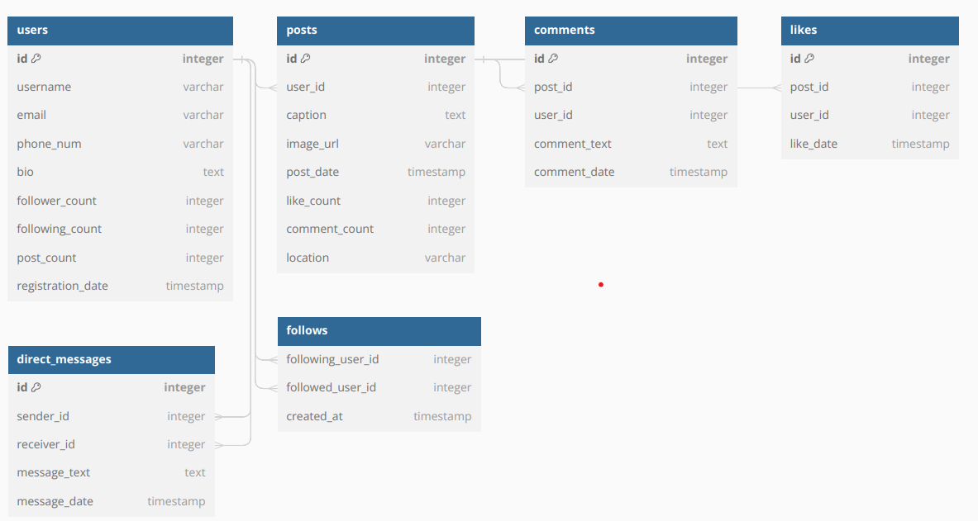

**Conclusion:**

This case study delves into Instagram's sophisticated data schema and Entity-Relationship diagram, which form the backbone of its dynamic social media platform. Instagram's success in the realm of social networking stems from its well-defined data model, comprising entities such as users, posts, comments, likes, and direct messages. This structured framework facilitates seamless interaction and content sharing among users, fostering a vibrant online community. By unraveling Instagram's data schema, we gain profound insights into its adept management of user-generated content, engagement metrics, user relationships, and messaging functionalities. Understanding Instagram's data architecture illuminates its prowess in cultivating user engagement, driving content discovery, and sustaining its prominence as a leading social media platform in the digital landscape.

**Submitted by :**

**Mohd Kaif Idrisi**